**Waterfall Charts**

Waterfall charts effectively display the cumulative effect of sequential positive and negative values. It shows where a value starts, ends and how it gets there incrementally. So we are able to see both the size of changes and difference in values between consecutive data points.

Tableau needs one Dimension and one Measure to create a waterfall chart.

## Creating Waterfall Chart

Using the Sample-superstore, let's plan to find the variation of Sales for each sub-category of Products. To achieve this objective we follow the below steps.

### Step-1

Drag the Dimension sub-category to the columns shelf and the Measure Sales to the Rows shelf. Sort the data in ascending order of sales value. For this use the sort option appearing in the middle of the vertical axis when you hover mouse around it. The below chart appears on completing this step.

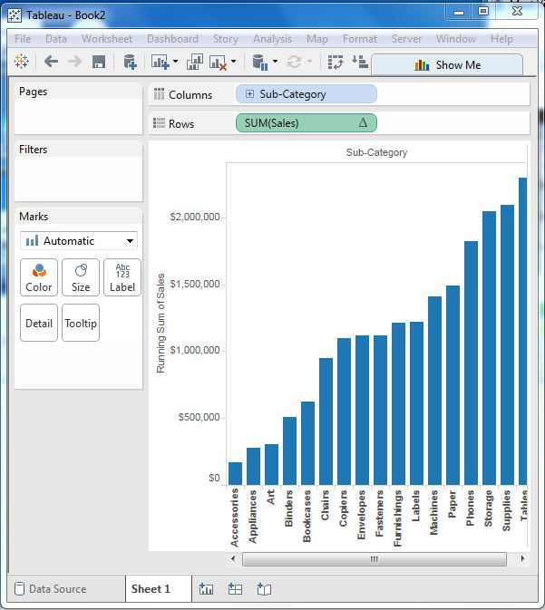

### Step-2

Next right on the SUM (Sales) value and select running total from the table calculation option. Change the chart type to Gantt Bar. The below chart appears.

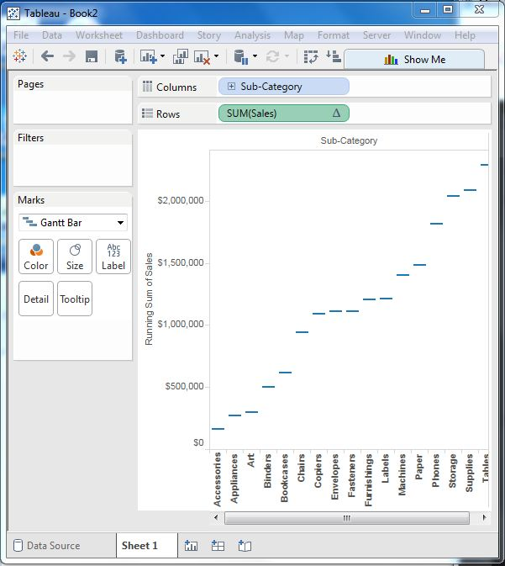

### Step-3

Create a calculated field named -sales and mention the following formula for its value.

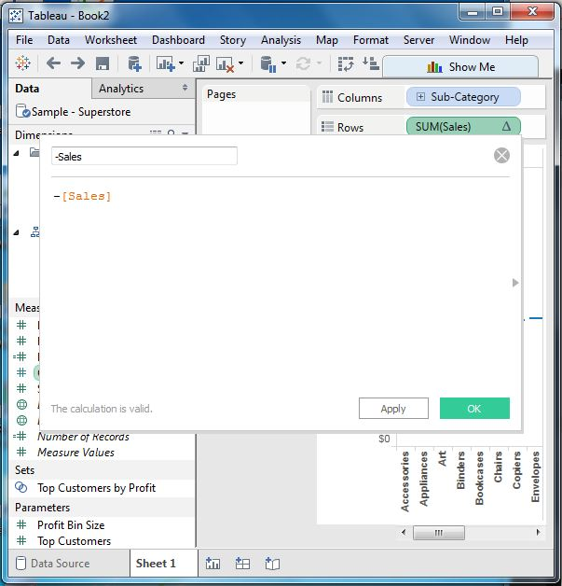

### Step-4

Drag the newly created calculated field (-sales) to the size shelf under Marks Card. The chart above now changes to produce the following chart which is a waterfall chart.

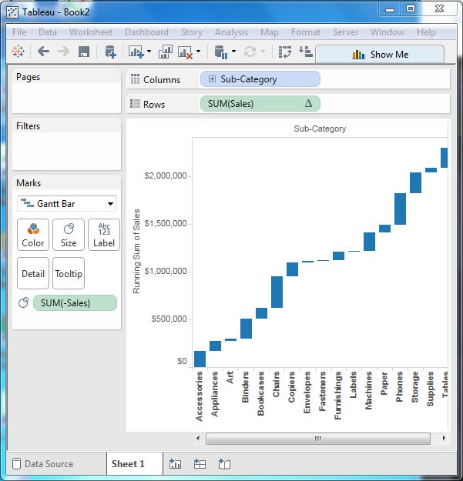

### Waterfall Chart with Color

Next we can give different color shades to the bars in the chart by dragging the Sales measure to the color shelf under the Marks Card. We get the below waterfall chart with color.

